- LINUX COMMANDS

- Pwd : To Know Present Working Directory

- who, w, whoami : for getting user details
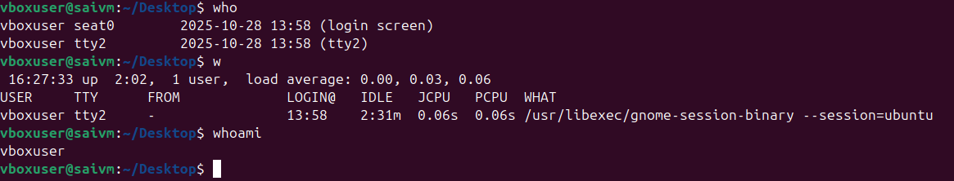

- uptime : For getting info on run time

- uname -a : for knowing version of terminal

- touch : for creating file and multiple files using space
- ls : for listing the created files
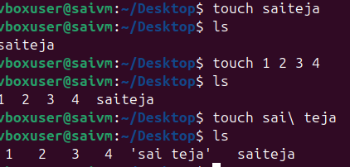
- touch file{} .txt : for creating multiple files using a single command
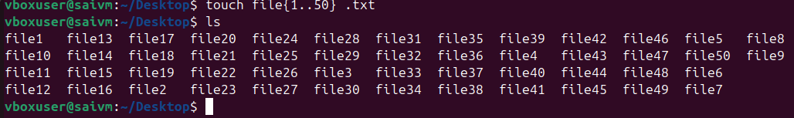

- mkdir : for creating folder or directory
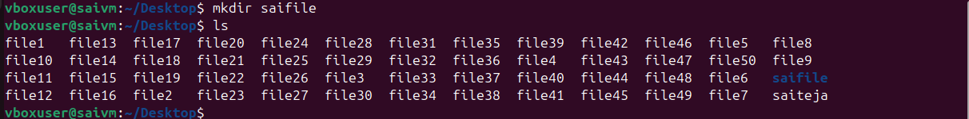

- cd : To change directory

- echo : To display text on the terminal

- ls: to list the files in vm or current directory

- cd .. : To go one step back

- cd ~ : to go directly to home directory
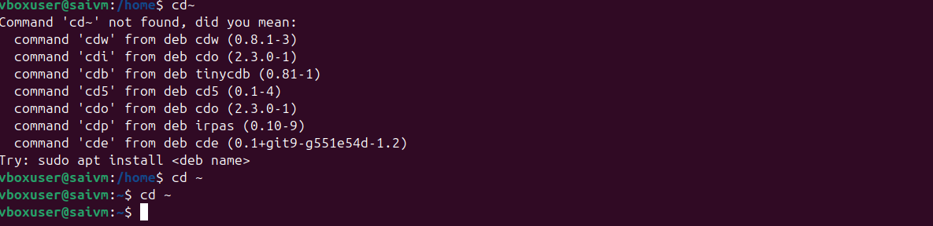

- ll : for list of files
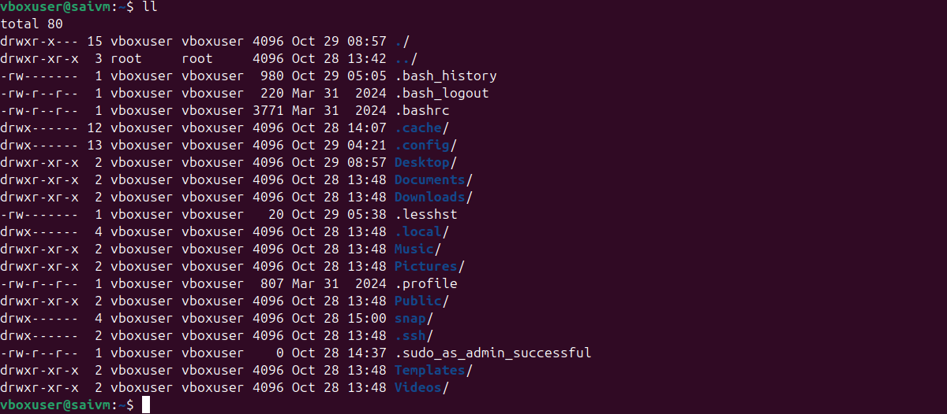
- ls -a : To see hidden files

- mv : To move files or folders
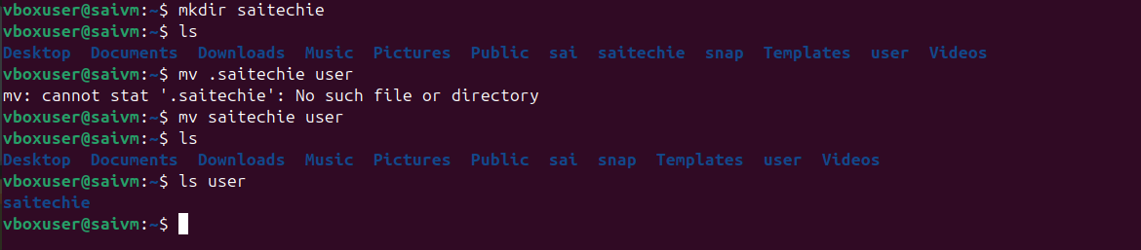

- Mv . : for renaming the files
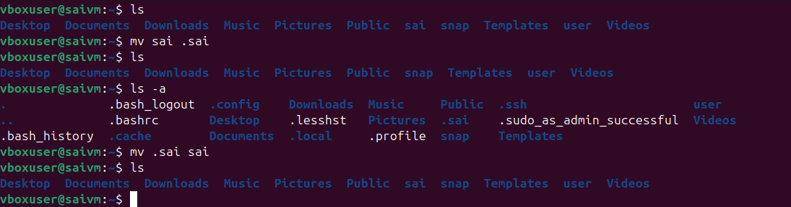

- History: To see previously executed commands
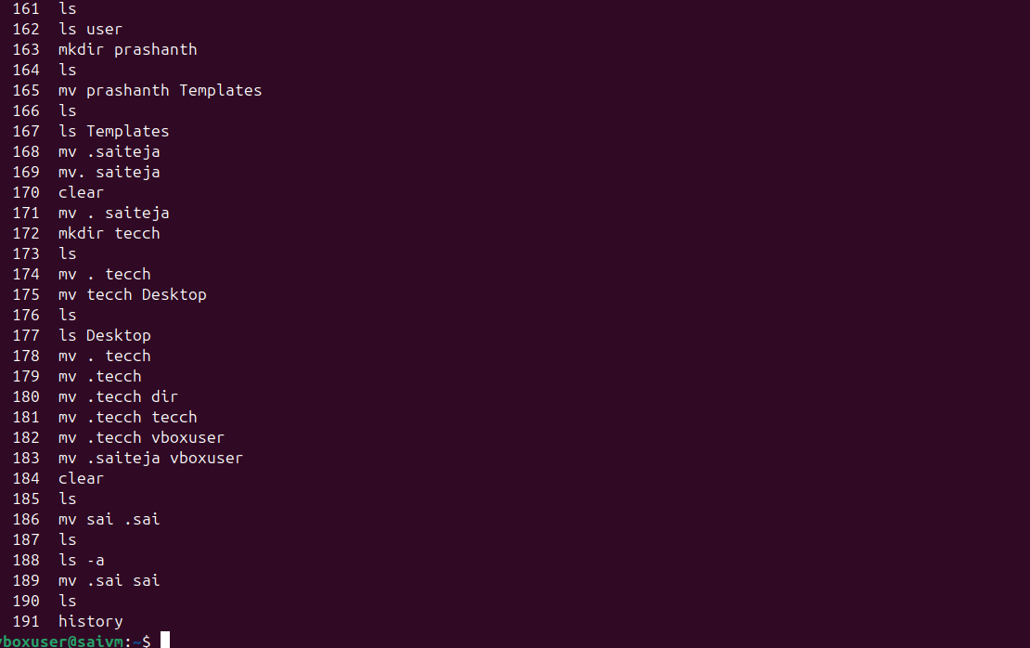

- rm -rf : remove or delete directories recursively and forcefully
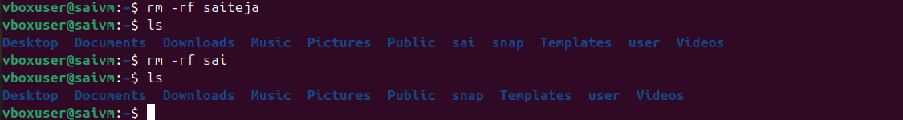

- clear : for clearing the terminal
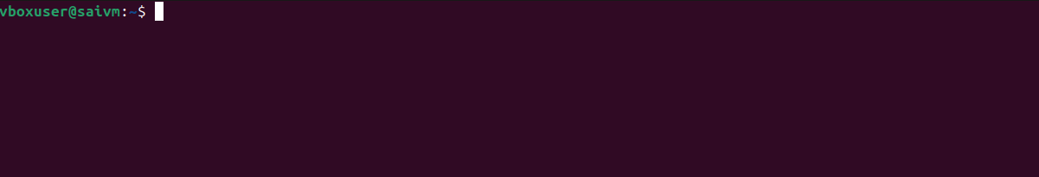

- vi : to create text inside file
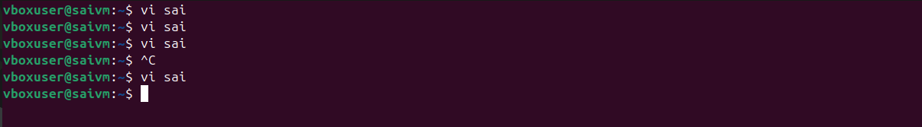
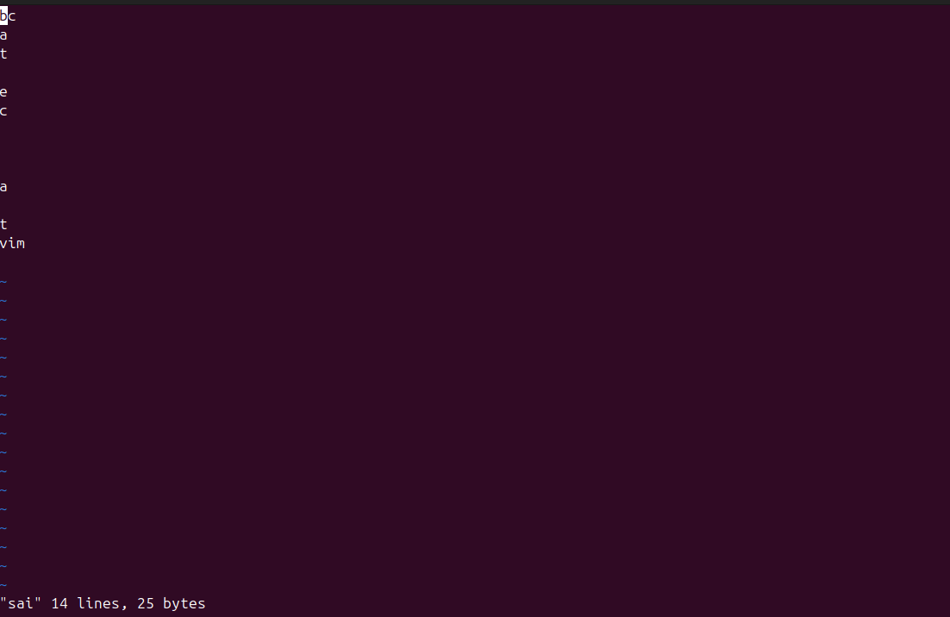

- cat : to view or combine files
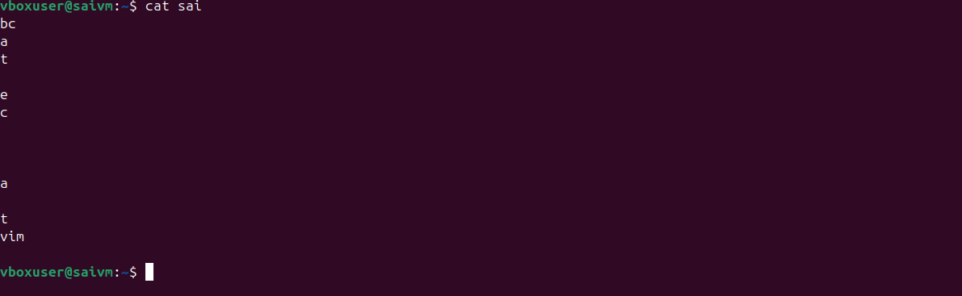

wc : to count lines, words, or characters ina file

